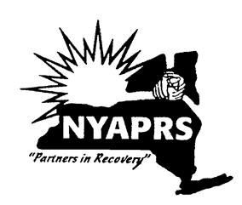
Going for the Goal!
Goal Setting for Getting Back on Track
FACILITATOR GUIDE

Description
Going for the Goal is designed to allow participants to identify life-role goals by examining their hopes and dreams. Participants will review mental health recovery, their need for change, core values and how they can use their strengths to mitigate barriers. At the end of the course, participants will set at least one goal from which to work on. The course guides participants through a step by step analysis of who they are and where they want to go. It is recommended that each participant attend each session in order to fully engage in the process of determining their life-role goals.
Purpose
The purpose of this group is to explore personal interests and strengths to identify a life-role goal.

Class Objectives:
- Demonstrate an understanding of goal setting and the importance of future planning.
- Describe their hopes and dreams and develop hope for the future.
- Explore satisfaction level within several life domains and compare with their interests and values.
- Identify, at minimum, one goal area to pursue and the steps in which to achieve it.

Facilitator Pre-Requisite Knowledge
Read Recovery Oriented Psychiatric Rehabilitation: Choosing a Valued Role; Presentation by Dr. Marianne Farkas, Boston University, PROS Academy 2016

SESSION ONE: Introduction to Course

Goals for Lesson One:
- Introductions to establish commonality and develop trust.
- Establish group norms to structure the conversations and support safety for all opinions and experiences to be heard without fear of judgement.
- Understand how recovery is for everyone.

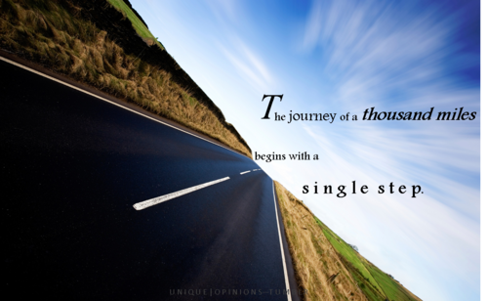

- Overview of Course
Description: Going for the Goal is designed to allow participants to identify life-role goals by examining their hopes and dreams. Participants will review recovery, their need for change, their values, strengths and set at least one goal from which to work on.

Purpose: The purpose of this group is to explore personal values, interests and strengths to identify a life-role goal.

- Introduction

The ‘My Name Is’ Ice Breaker

My Name Is
Go around the group and ask everyone to state his/her name and attach an adjective that describes you and also starts with the same letter of your name e.g. Dynamic Dave.
Write them down and refer to them by this combination of names for the rest of the class.

- Group Norms/Rules
Group Norms/Rules are set collaboratively with the group. Some typical Group Norms are:
- Start on time
- End on time
- Respect everyone’s opinions - even if we disagree
- Allow everyone to get some time to speak
- No crosstalk

As a general rule of thumb, do not have too many, have them come from the group with your direction if necessary. Post the Group Norms at every group as this helps people to self-regulate their behaviors and also serves to educate new incoming participants.

- What Do We Have in Common?

After the My Name Is introduction exercise and after establishing the group norms, ask the participants to share what they think they may have in common with others in the room. As people are talking, write on a board/large note pad (or have a volunteer from the group) the commonalities people are sharing. Use this as an opportunity to elicit responses that include:
1. People caring for themselves by seeking the support of PROS
2. Willingness to participate in this course
3. Desire to see a different future for themselves

Reframes: When someone shares something negative, for example, ‘We are all here because we are sick.” A possible reframe you can employ is, ‘What I’m hearing is that everyone here has a shared experience of working on their mental health.’ The Facilitator’s reframes are important throughout the course. It models a strengths-based approach, builds hope, and supports safety.

- Why set goals?

Most people want to see some kind of change or improvement in their lives from time to time. Setting goals doesn’t just happen once, it happens throughout our lives. Setting goals is an effective way to increase motivation and enable people to create the changes they desire. It can be used to improve health, relationships, productivity.

Setting goals is a good way to focus attention on the things that are important. It allows us to create a vision of how we would like our life to be. People tend to increase the amount of time and effort spent on an activity, and develop effective strategies when they have a goal to achieve.

PROS and You: We recommend that you take advantage of your time with PROS to have us assist you with goal setting and in achieving your goals to experience the fuller life you want.

- What is goal setting?

Goal setting is the process of planning for the future and thinking about what you want out of your recovery journey and your life. Setting personal goals—big and small—can help you focus on what’s important to you.
Learning how to set goals and achieve them can help you live the life you want while managing your mental health recovery. When you set your own goals, YOU are in control and you decide what success looks and feels like to you.
Identifying a rehabilitation goal is choosing a preferred environment in which you intend to live, learn, work or socialize. This is followed by setting a time frame in which you will accomplish this. Typically within the next 6 months to 2 years.

NOTE: Recovery Goal and Rehabilitation Goal
in this context are synonymous.

Setting an Overall Rehabilitation Goal is part of your care and treatment in PROS. To help you develop the skills and resources that you need to use to be successful and satisfied.

Skills + Supports = Success + Satisfaction

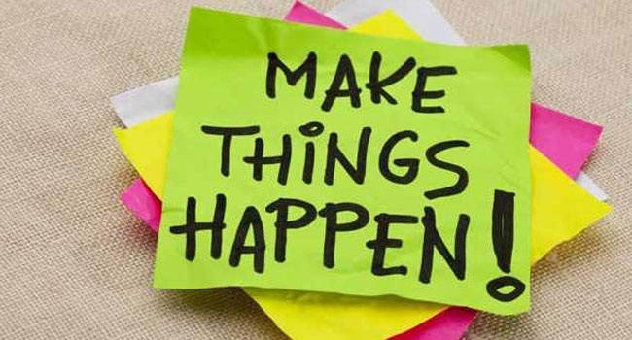

Materials for Session: Ice Breaker Description
SESSION TWO: Recovery as the First Step
Goals for the Lesson:
- Demonstrate an understanding mental health recovery
- Explore recovery for yourself

People don’t always think about ‘recovery’ from mental illness. It is a proven fact, that people can and do find recovery. The definition of recovery is different depending on who you ask. It is different because people are different and what you want out of life is different. Here are two definitions of recovery.

“Recovery is a deeply personal, unique process of changing one’s attitudes, values, feelings, goals, skills and or roles. It’s a way of living a satisfying, hopeful and contributing life even with limitations caused by illness. Recovery involves the development of new meaning and purpose in one’s life as one grows beyond the effects of mental illness.”
(Anthony, Cohen, Farkas, Gagne, Psychiatric Rehabilitation, 2002)

A process of change through which individuals improve their health and wellness, live a self-directed life, and strive to reach their full potential.
SAMSHA 2011

Recovery is the ‘gaining’ of something you desire in your life and not the removal of something. When thinking about what recovery means to you, remember that you are unique and that your vision of recovery for yourself will be different from others. With recovery, we welcome a new life with new possibilities.
Historically, people’s goals were focused on the ‘removal of symptoms’. Over time, we realized this was a limited view and only one aspect to a person’s recovery. We can achieve so much more when we do not limit our lives. If we decided to give up on our goals and our future until our symptoms were gone, we may very well never live a full life.
When we understand recovery, we learn that we are more than just a person with mental illness. We are people… people with hopes and dreams and we have every right to achieve them and live life to its fullest.
To understand recovery and how to live a life of our choosing, let’s look at recovery, as the first steps we take on our journey.
Recovery Principles
- Recovery is possible.
- Recovery can occur without professional intervention.
- Recovery involves more than symptom reduction and can occur even though symptoms reoccur.
- Recovery is not linear.
- Recovery is a highly individualized process.
- Recovery occurs in the presence of someone who believes in and stands by the person.
- Recovery from the consequences of the illness is sometimes more difficult than recovering from the illness itself.
Anthony, W.A. (1993) Recovery From mental Illness: The Guiding Vision of the
Mental Health System in the 1990’s. Psychosocial Rehabilitation Journal, 16 (4), 11-23
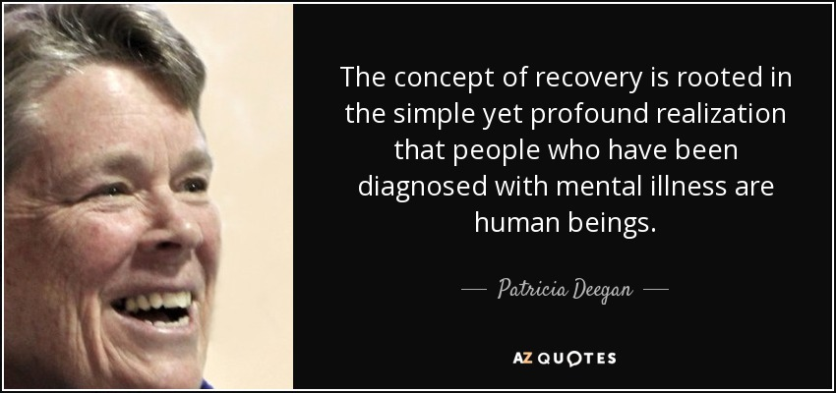

What does Recovery Mean to Me (Pat Deegan)?

To me recovery means I try to stay in the driver’s seat of my life. I don’t let my illness run me. Over the years I have worked hard to become an expert in my own self-care. Being in recovery means I don’t just take medications … rather, I use medications as part of my recovery process …
Over the years I have learned different ways of helping myself. Sometimes I use medications, therapy, self-help and mutual support groups, friends, my relationship with God, work, exercise, spending time in nature – all these measures help me remain whole and healthy, even
though I have a disability.
Pat Deegan, 1993

SOME PROFOUND EXAMPLES OF RECOVERY:

- Opening a bank account
- Not eating alone
- Buying cards and presents for family and friends
- Making meaningful contributions to the lives of others (giving back)
- Working, learning, loving, and playing like everyone else

Who is Recovery for? Everyone

Who is Pat Deegan?

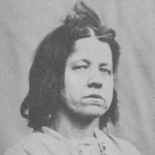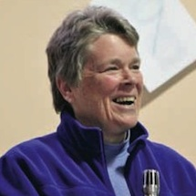

Patricia E. Deegan is a disability-rights advocate, psychologist and researcher. She is a thought leader, inspirational speaker and innovator in the field of mental illness. She is also a person who has mental illness, having been diagnosed with Schizophrenia as a teenager.
- What Does Recovery Mean to Me?
Pat Deegan has touched many lives through her profound personal experience with mental illness and her path to recovery. She has been able to break down simple yet profound steps people can take as part of their recovery path. As we mentioned earlier, she said, ‘not eating alone’; ‘having a bank account’, etc. Recovery does not have to be complicated.

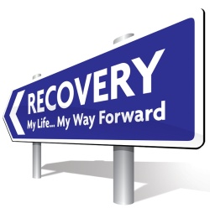
Exercise: What Does Recovery Mean to Me?
(3 Minute Exercise)
Let’s take a moment to write down our first impressions of what recovery means to you. This exercise is intended to be quick. Write down the first 3 things that pop into your mind as you think about what recovery means to you. Do not overthink your choices as this is not intended to limit any future options.

- _______________________________________________________________________________________________________________________________________________________________________________________________________________

- _______________________________________________________________________________________________________________________________________________________________________________________________________________

- _______________________________________________________________________________________________________________________________________________________________________________________________________________

After two minutes, regardless of whether people have written one or three, ask for volunteers to share what recovery means to them. Use the flip chart to write what people have shared. Highlight some of the similarities and differences.

We are each unique individuals and in the same way, our recovery is unique. That’s why it’s important to explore ourselves, what we think, feel and value in ourselves and in life. This helps us understand ourselves better.
We have all had dreams of what and who we wanted to be when we were younger. Those hopes and dreams can morph or change over time depending on our experiences. Some of us have experienced setbacks and we have put our hopes and dreams aside. They may even have changed from when we were young, but humans change and grow every day and so can we.

- Conclusion:
Pat Deegan is one voice – a very powerful voice – in advocating for the rights of people with mental illness. Through her voice, people have found inspiration to live their best life.

Recovery from mental illness does not mean the absence of symptoms, but it does mean going for your dreams. You may still have symptoms to overcome but you can live your best life while working to reduce your symptoms. You can manage symptoms various ways that include more than medication. It can include exercising, eating healthy, having friendships, being social and going out, talking with family, etc. To be able to live and work and have relationships; to have a life and to make mistakes and learn from them and to pick ourselves up again when we stumble. We all can live a full life when we think about ourselves and our WHOLE LIFE. We are more than an illness.

YOU are resilient and you can live your best life!
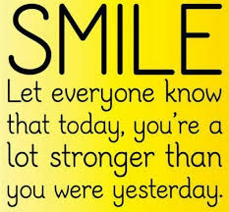

Materials for Session: ‘What Does Recovery Mean to Me’ form; pen/pencil; flip chart or blackboard; markers or chalk.

SESSION THREE: Exploring My Readiness for Change
It’s not easy to be certain if you even want to change any aspect of your life. Sometimes we know something is just not right. Our life is not what we planned or hoped it would be. But it’s sometimes easier to keep our life the same, even if we are not really happy with it. Today’s class will focus on our need for change and it will help us to identify what that is. First, let’s review the steps we will go through for this exercise, then we will review an example and then we will fill it out ourselves.

Facilitator: You determine how much of the below is needed for review.

Outline of the Steps of Need for a Change

Step 1: Which area in my life do I want to focus on at this time?
- Pick one area of your life to explore first (living, learning, working, or socializing).
- Pick the area that you think you’d like to work on the most right now.
- Name the place that you are focusing on (living, learning, working, or socializing) and your role, such as resident, student, part‐time cashier, or club member.

Step 2: How happy am I with the people, the place, and the activities at my current place?
- Answer the questions on the worksheet about how satisfied you are currently in the
area in your life that you picked to explore first, using the scale.
- If you are not currently in the type of place you are focusing on, record how you feel
about not being in that setting. For example, if you are unemployed, then how
satisfied are you with having no job at this time?

Step 3: How well do I think I’m doing here? How well do others think I am doing here?
- Answer the questions on the worksheet about how successful you are currently in
your focus area, using the scale provided.
- If you are not in the type of place you are focusing on, record your thoughts about
your success. For example, if you are unemployed, then how successful do you feel?

Step 4: Given both my satisfaction and my success in my current place, how would I rate
my need to choose a valued role now?
- Summarize your Need for a Change using the scale on the worksheet.
- If the rating for your Need for a Change is “Very Low,” which means that you are
very satisfied and very successful there, then pick a different area of your life that
you’d like to explore and start the steps of Need for a Change again.
- Sometimes after you explore the other parts of readiness, you will discover that your
- Need for a Change fluctuates. An original “Very Low” rating can change when you
learn more information and discover other options are possible for you.
Mike’s Example of Need for Change

Name: Mike Smith

Step 1: Which area in my life do I want to focus on at this time?
Living Learning Working Social
Name of my Current Place and Role in this Area: Resident at Main Street Adult Home

Step 2: How happy am I with the people, the place, and the activities at my current place?

Need | Very Dissatisfied | Mostly Dissatisfied | Mixed | Mostly Satisfied | Very Satisfied
How satisfied am I with the people in my current place? |  | I don’t really like the other residents.
How satisfied am I with the physical aspects of my current place? |  | Nice TV, but I can’t watch what I want and I have to share a bedroom. I have no privacy. I can’t get healthy because I smell other people’s cigarettes.
How satisfied am I with the activities in my current place? | I’m bored w/ activities, and annoyed w/ chores.
Step 3: How well do I think I’m doing here? How well do others think I am doing here?
Need | Very Unsuccessful | Mostly Unsuccessful | Mixed | Mostly Successful | Very Successful
How successful do I think I am in my current place? |  |  | I think I’m okay. I do everything they ask me to but I have no choice.
How successful do others think I am in my current place and role? |  |  | Some + / - mixed reviews from others

Step 4: Given both my satisfaction and my success in my current place, how would I rate my need to choose a valued role now?
Circle One
Need for Change Rating | Very High | High | Moderate | Low | Very Low

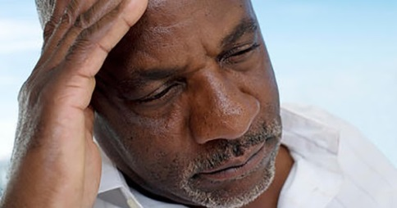
In this example, Mike chose a life area to focus on. He chose ‘Living’ and he answered the questions based on that. By going through this process, Mike is able to see that he is not very satisfied with his living environment. He is a resident in an Adult Home and while it’s a roof over his head, he can’t really do what he wants there. He has to share a television and that means he doesn’t always get to watch what he wants. He also has a roommate and that can sometimes be hard to deal with. He has very little privacy.
In the end, he rated his need for change as ‘high’. This now guides Mike as he plans to create a goal to change his circumstances.

Continue to focus on ‘Living’ and discuss what it’s like to live in a place where one has no privacy and choices are limited. Going through these questions with the group is very important as this group is primarily focused on helping people living in Adult Homes get the motivation to get into more independent housing. These questions are focused on Mike Smith and the example of Need for Change. By focusing on Mike and not on themselves, people can be more objective while it may also resonate with their life and level of dissatisfaction.

- Do you think this is how Mike imagined he would live?
- Can anyone relate to Mike’s dissatisfaction with living in an Adult Home?
- It’s called Adult Home, but do you think it feel like a ‘home’?
- Most people do not live in Adult Homes. What kind of places do people live in? (share some examples if need be. (E.g. apartments, houses, rented rooms with family or friends…)
- Since Mike rated his dissatisfaction level at ‘high’, what do you think his goal should be?
- If Mike chooses to leave the Adult Home in order to be in his own place, what sort of things you think he needs to work on in order to achieve that goal?
- When Mike gets his own place, how do you think he will feel?
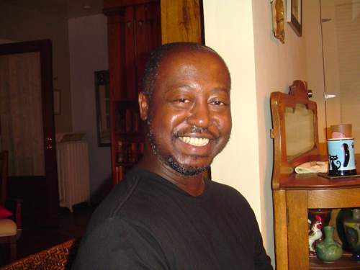
This looks like Mike is in his own place and he looks happy!
We will now go through this exercise ourselves. Use the blank ‘Need for Change’ form and answer the questions. Choose an area of your life that you want to focus on and then answer the questions. At the end, we will review your together and have a discussion based on your answers.
If you have questions, feel free to ask and I will come around to help everyone.
My Worksheets for My Need for a Change (page 1 of 2)

My Name: ____________________________________________________________________
Step 1: Which area in my life do I want to focus on at this time?
Living Learning Working Social
Instructions: Write down the name of where you are living, learning, working, or socializing. Write down your role there, such as resident, student, part-time cashier, club member, etc.
Name of my Current Place in my Area of Focus: ______________________________________
What is my Current Role here? ___________________________________________________

Step 2: How happy am with the people, the place, and the activities at my current place?
Instructions: Write your comments on the rating that best matches your satisfaction level for each of the qu3estions in the left-hand column. If you are not in the type of place you are focusing on, record how you feel about the lack of setting. For example, if you are unemployed, then how satisfied are you about having no job at this time?
Need | Very Dissatisfied | Mostly Dissatisfied | Mixed | Mostly Satisfied | Very Satisfied
How satisfied am I with the people in my current place?
How satisfied am I with the physical aspects of my current place?

How satisfied am I with the activities in my current place?

Step 3: How well do I think I’m doing here? How well do others think I am doing here?

Instructions: Write your comments in the box that best matches your success level for each of the questions in the left-hand column.
Need | Very Unsuccessful | Mostly Unsuccessful | Mixed | Mostly Successful | Very Successful
How successful do I think I am in my current place?

How successful do others think I am in my current place and role?

Comments:

Step 4: Given both my satisfaction and my success in my current place and role, how would I rate my need to choose a valued role now?
Instructions: Circle the rating that best describes your Need for a Change now based on your exploration of your satisfaction and your success. For example, a ‘Very High’ Need for Change rating means that you were very dissatisfied and very unsuccessful in your current place, and a ‘Very Low’ rating means that you were very satisfied and very successful in your current place.

Circle One
Need for Change Rating | Very High | High | Moderate | Low | Very Low

After everyone has completed their form, lead the group in a discussion about their answers and use a flipchart or chalkboard to document what is shared. Use this as an opportunity to explore their level of dissatisfaction with one or more areas of their life. If anyone chooses ‘Living’ as an area of dissatisfaction, compare their dissatisfaction to Mike’s in the previous example. Review the following questions with the group:

- This reminds me of our previous example, where Mike was dissatisfied with living in an Adult Home. What things do you think you have in common with Mike?
- I think many people who live in Adult Homes have some dissatisfaction as well. Do you know anyone who feels the same way you do?

Homework Exercise
When you return to your Adult Home today, consider your experience in this class today and what you have discovered about yourself. Look around and think of what happens there to cause you to be dissatisfied and then think of your living on your own. Ask yourself this question: How would my life be enhanced by living on my own? During the next class, we will discuss how this homework exercise went.

Materials for Session: ‘Need for a Change’ form; pen/pencil; flipchart or chalkboard; marker or chalk.

SESSION FOUR: Personal Core Values
Goals for the Lesson:
- Demonstrate an understanding of goal setting and the importance of future planning
- Explore and identify priority values

Open the group discussion with an overview of the work from the previous class on Need for Change. At the end of that class, a homework assignment was given for people living in Adult Homes to ask themselves this question: How would my life be enhanced by living on my own?
Explore their answers. Your goal here is to continue to explore levels of dissatisfaction in the area they identified but most specifically, with those living in Adult Homes or other types of residences where they are not independent.

We have established, to some extent, levels of dissatisfaction in one or more areas of your life.
- What do you think the next logical step should be?
If you are imagining the next step would be to create your goal and then plan on how to achieve it. Well, that does make sense, but it’s not quite the next step. Planning is not always easy and we want to ensure that we are creating a goal that you want and that is in keeping with your life values.
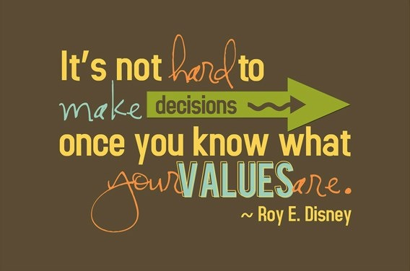
Roy Disney is co-founder of the Disney franchise with his brother, Walt.

- Core Values
Understanding values entails having a clear sense of what we care about. When we are connected to our values, we will have a clearer understanding of what motivates our behavior. Values define what is important to us. They are reflected in our hopes, dreams, desires, goals, and ambitions. Values, like feelings, indicate who we are. Values are an extension of our beliefs about the world and attitudes toward life. They are formed over time through a series of life experiences, including our interactions with family, school, and community. Values provide guidelines for making decisions that are right for us. Understanding the specific values that guide our behavior helps us to clarify the significance of more general values, such as those pertaining to family, work and spirituality.
Some values play such a central role in life that it would seem we should be able to articulate them clearly. Unfortunately, some of us can’t. We may have a vague idea of what is important to us and live our lives based on an imprecise understanding of our values. When we suffer from inner conflict, it is usually because we are unsure of our values and we do not know how to decide which values are the most important.

People often confuse goals and values but in reality they are quite different. Goals tend to be specific and achievable, and they can be checked off and completed. Values represent what is important to you in life and they tend to be constant. Values cannot be completed or finished. Goals are successful when they are based on our values. For example, if family relationships are an important value, some related goals could be to reconnect with a family member; or to increase time you spend with family, etc.

You want people to begin to think about what they value in life. Elicit examples of their Values. Examples of life values:
- A belief, or lack thereof, in God and/or an affiliation with a religious institution
- A belief in being a good steward of resources and in exercising frugality
- A belief that family is of fundamental importance
- A belief that honesty is always the best policy and that trust has to be earned
- A belief in maintaining a healthy work/life balance

Hope grows when we realize that we have the ability to act in accordance with our values, and when we believe that our values can be realized within the world.

Identifying Our Values (there are 2 exercises to choose from)
Our core values are the true representation of our authentic selves. Unfortunately, our authenticity is not always what we present to the world. The bright beacon of core values may dim under clouds other people and circumstances cast over them. That is why it is important to know and stand firm on what your core values are. If you put a small value on your core values, I can assure you that the world will not raise your price.
It doesn’t take years of soul searching and self-reflection to find your core values. The following exercise can help you start living your best life according to your core values in 30 minutes or less.
Grab a pen and piece of paper and let’s go!
Exercise Option 1:

In the space below, write down your physical, emotional, intellectual, and spiritual values relative to home or work – then weight them according to their relative level of importance. Use a 10 to indicate your most important values and 1 to indicate your least important values. Assign relative weights to all the others. You can use the same number more than once. Pick two or three values for each category. You can use the list of some possible Core Values to help you with this exercise.

Example from Mike Smith
Physical Values: |  | Intellectual Values:
Fitness | 8 | Contribution | 7
Appearance | 6 | Quality | 8
Activity | 5 | Challenge | 6
Emotional Values: |  | Spiritual Values:
Adventure | 7 | Meaning | 10
Love | 10 | Trust | 10
Commitment | 10 | Forgiveness | 7

Physical Values: |  | Intellectual Values:
Emotional Values: |  | Spiritual Values:

List of Some Core Values

Acceptance  Accountability  Achievement  Adventure  Advocacy  Ambition  Appreciation  Attractiveness  Autonomy  Balance  Being the Best  Benevolence  Boldness  Brilliance  Calmness  Caring  Challenge  Charity  Cheerfulness  Cleverness  Community  Commitment  Compassion  Cooperation  Collaboration  Consistency  Contribution  Creativity  Credibility  Curiosity  Daring  Decisiveness | Dependability  Diversity  Empathy  Encouragement  Enthusiasm  Ethics  Excellence  Expressiveness  Fairness  Family  Friendships  Flexibility  Freedom  Fun  Generosity  Grace  Growth  Flexibility  Happiness  Health  Honesty  Humility  Humor  Inclusiveness  Independence  Individuality  Innovation  Inspiration  Intelligence  Intuition  Joy | Knowledge  Leadership  Learning  Love  Loyalty  Making a Difference  Mindfulness  Motivation  Optimism  Open-Mindedness  Originality  Passion  Performance  Personal Development  Proactive  Professionalism  Quality  Recognition  Risk Taking  Safety  Security  Service  Spirituality  Stability  Peace  Perfection  Playfulness  Popularity  Power  Preparedness  Proactivity | Punctuality  Relationships  Reliability  Resilience  Resourcefulness  Responsibility  Responsiveness  Security  Self-Control  Selflessness  Simplicity  Stability  Success  Teamwork  Thankfulness  Thoughtfulness  Traditionalism  Trustworthiness  Understanding  Uniqueness  Usefulness  Versatility  Vision  Warmth  Wealth  Well-Being  Wisdom  Zeal

Exercise Option 2:
In this exercise you will be using the skill of understanding your values by placing them in the context of your life.

To help you focus on your values, assume for a moment that you have won the lottery. Write (or use a verbal interactive style) a story about what you would do with the money. Use these thoughts to get an even clearer picture of what is important to you.

- What would you do with your time?
- Where would you go?
- With whom would you spend your time?

Clarifying Values
Clarifying Values broadens our knowledge about what is and what is not important to us. We need to know what is important to us before we choose an environment. The more our chosen environment matches our values, the more likely we will be satisfied with our choice.

Closing:
Review the accomplishments of this session, individually and collectively. Everyone is getting to know each other and themselves. The goal is to build trust and safety so that everyone can learn from each other, themselves and the facilitator. Everyone is one step closer to connecting goals to their values. Ask the participants to share how they feel the session went. It’s important to take the temperature of the room as this will help shape the classes to come.

Some people may not finish this exercise. If not, they can complete for ‘homework’ or you can extend the exercise to the next class if the majority of the group needs more time.

Materials for Session: Identifying Our Values exercise 1 and 2; pen/pencil and paper.
Resources: http://examples.yourdictionary.com/examples-of-core-values.html#qJbyDw4hQy2HUlTW.99; http://www.taproot.com/archives/37771; The Recovery Workbook II: Connectedness: Boston University 2003.

SESSION FIVE: Using My Strengths to Overcome Barriers
Goals for the Lesson:
- The goal of this lesson is to identify personal strengths.
- Understand how strengths can help overcome barriers.

The previous session on our Core Values was the first step in helping you to identify a goal (or goals) that you are most interested in achieving. When you are able to connect your values to your goals and to understand the connection, you get to know a little bit more about yourself.

We want to examine our identified Core Values from the previous session.

- What were they?

The facilitator is to lead the group members through the values they identified from the previous session. Connecting Core Values to Goals can be complicated, so walk people through the exercise at a pace that they are comfortable with. If they are not able to grasp this concept, they may feel lost for the rest of the class.

Personal Strengths: We’re now going to jump into examining our Personal Strengths. We all have different personal strengths and abilities. Sometimes it can be hard to remember them when we are going through tuff times. Knowing our strengths will help us work towards and accomplish the things you want from your life. The following statements may help you identify some of your own.
My Personal Strengths Exercise:

My best qualities as a person are ___________________________________________________
____________________________________________________________________________________________________________________________________________________________

Something I would NOT change about myself is _______________________________________
____________________________________________________________________________________________________________________________________________________________

I am most proud of ______________________________________________________________
____________________________________________________________________________________________________________________________________________________________

My sense of humor is ____________________________________________________________
____________________________________________________________________________________________________________________________________________________________

The times I am most at peace are when _____________________________________________
____________________________________________________________________________________________________________________________________________________________

People like that I am (people say they like my…) _______________________________________
____________________________________________________________________________________________________________________________________________________________

I feel really good about myself when ________________________________________________
____________________________________________________________________________________________________________________________________________________________
- Using our Strengths to Get Back on Track

Recovery is deeply personal and it helps us to move on from moments in our past where life took a turn we didn’t expect. Recovery gives us hope and courage to face the path you set for yourself. It is a journey we all experience at some level and at various times in our lives. Barriers have the ability to stop us in our tracks and we - - get off track in our lives. We have all been there. That is one thing we all have in common with each other.

The next phase is to beginning planning our future. Planning takes courage and you are all courageous! We will get back on track by creating goals we want to achieve. We will use all the information you learned about yourself throughout this course so far to plan your future. As in all things, we want to take this one step at a time in order to be mindful of barriers and work our way through them by using our strengths.

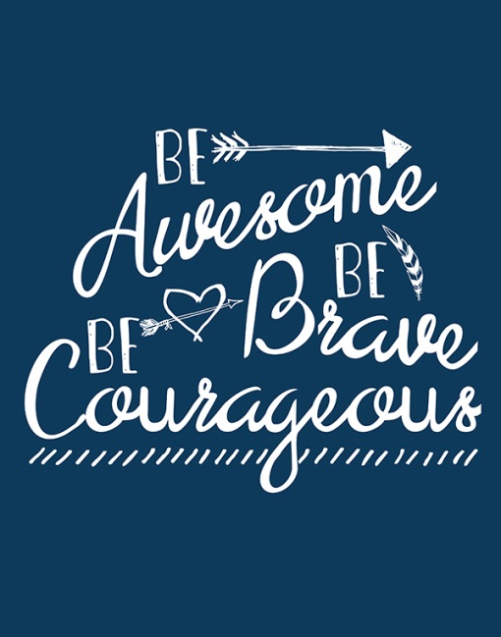
Example: Strengths and Barriers
I may encounter a problem with a family member, who disagrees with my decision to live on my own. I know that my family loves me but they keep thinking about my past. How can I help them see that my future is not defined by my past?

- I have some strengths I can call upon!
- I love my family.
- I am scared about them being upset with me but I can communicate my hopes and dreams to them.
- I am determined to achieve my goal of living on my own.
- I am proud of myself for making this decision!
- I am an understanding person so I know that my family loves me even if they are upset.
- I am resilient and I know I will be able to live on my own with help.
- I will accept support from family, friends, church, community, PROS, Care Management, etc. to help me be successful.
- I am motivated to learn the skills I need to be successful.
- I am scared but I am prepared to be in control of my life.
- I will remember that my family loves me even if we disagree.

Using My Strengths to Overcome My Barriers Exercise:

You can use the list of Core Values to help you.
A barrier I may encounter is:

______________________________________________________________________________________________________________________________________________________________________________________________________

Strengths Statements
1.
2.
3.
4.
5.
6.
7.
8.
9.
10.
Review everyone’s strengths and how they will use their strengths to deal with barriers they may encounter as they work to achieve their goal.
The facilitator will need to take a very active role in this discussion and be prepared to use reframes when people get stuck or have doubts. We want to ensure to reinforce their planning success so they maintain motivated to continue. Sometimes when people lose hope, we need to lend them ours until their confidence and hope return.

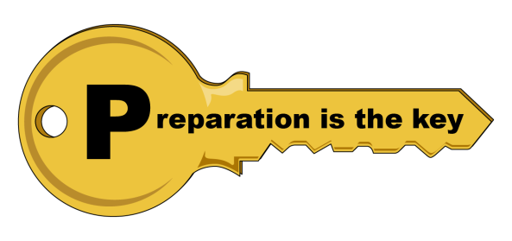

I’m ready to write my goals!
WONDERFUL! The rest of the class will focus on honing down your goal so that it’s not too broad or too unmanageable. As we discussed, we want to prepare for the barriers that may get in our way to living our goal. Goal statements with incremental steps help us to have more control of the process. It also helps us to feel successful! When one piece of the goal is completed, celebrate because you will be one step closer to your goal!

Materials for Session: My Strengths Exercise Form; Using My Strengths to Overcome My Barriers Form; pen/pencil

Resources: The Recovery Workbook II: Connectedness: Boston University 2003.

SESSION SIX: My Goals

RECAP:
In the last five classes, we’ve discovered a lot about ourselves! We have explored areas that we would like to change. We’ve explored our values, feelings, potential barriers and our personal strengths we can use to face them.
All of this knowledge will be put into action today! We will determine our goals and write them out.

Exercise: What if I Still Have No Goals? No Sweat! (5 minutes)
Ask each person (whether they have goals or not) to visualize an ‘ideal day’. The duration of this exercise is short because this is intended to capture a person’s first thoughts.

- What would this look like? ____________________________________________________________________________________________________________________________________________________________

- What would you be doing? ____________________________________________________________________________________________________________________________________________________________

- Who would be with you? ____________________________________________________________________________________________________________________________________________________________

- Generating Person-Centered Goals
What do we mean by Person-Centered goals? Well, this is typically when goals are stated in your own words and using positive strengths-based language, e.g. “I want to be less depressed so that I can finish college.” The ‘less depressed’ part of the goal focuses on symptoms but that alone is not a goal. A goal includes identifying a life-role that you want to achieve. In this example, the person wants to be less depressed so that they can become a student to finish college.

Advice: You may find that a goal you create is not quite in keeping with a clinician’s idea of a goal for you. This is okay and it’s a perfect time to have a discussion together. These are your goals. Clinician’s want you to be successful, and we may have some opinions. We will explore this with you by asking you questions to help you think about and consider your choices and options. By having a discussion with a staff member, this will allow you to get additional input and ideas. In the end, the goal is yours.

Setting person-centered goals and writing them using first person language doesn’t mean that we agree with people’s goals. Use motivational interviewing and strengths-based counseling to help them understand your opinion and the options they have. If we force our opinions onto people we may find that they will disengage because they are not being heard.

“To be able to participate in person-centered care, first you have to believe that you have the right to be a person” - - Ed Knight

PUTTING IT ALL TOGETHER

In this next section, we will do a very brief overview of the topics we have reviewed during this course. It serves as an opportunity for people to see all of the work they have achieved and how it all leads to creating their goal statement.
You may find that people will need to reference the actual work they have completed thus far so as to help guide their thought process towards creating their goal statement. Ensure they have access to the folders they are keeping for this course.

We’ve achieved so much!
- Which area of my life do I want to focus on at this time?
Living Learning Working Social

- I have identified my Need for Change Rating
- I have identified my core values
- I have identified my personal strengths
- I have identified how my personal strengths can help me overcome a potential barrier

The next step is to write my goal statement!
Reframe
If people are focused on symptoms – For example, “I want to feel less depressed” ask them these questions to help them begin to shift their thinking from lack of symptoms to adding roles to their life.

If you were less depressed, what might you be doing?
What kinds of things would you enjoy?
How would life be different for you?

People may need extra help to articulate their goals but it doesn’t mean they don’t have any.

Wellness is not always about ‘removing’ symptoms. People can manage symptoms while living their best life.

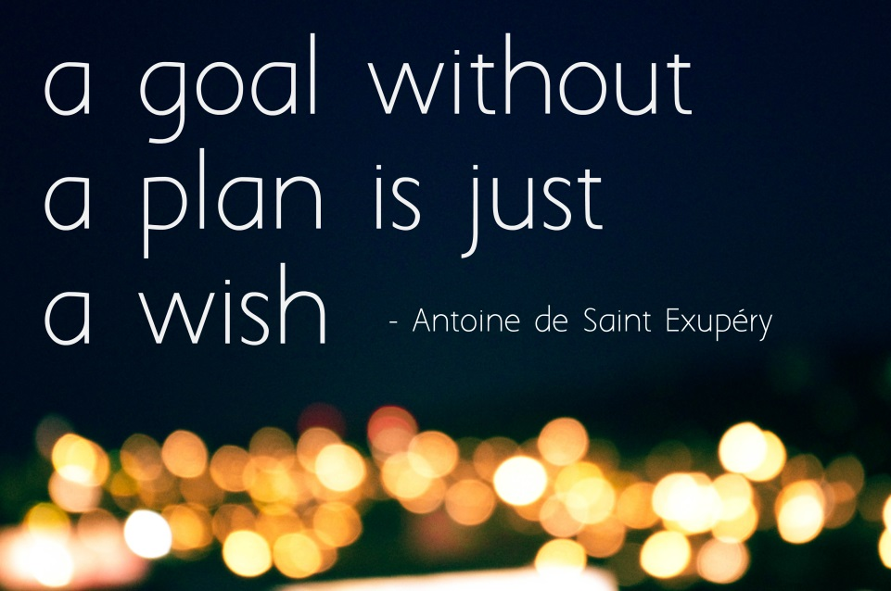

My Goal Setting Worksheet

Name: Mike Smith
Life Area to Improve:
Living Learning Working Social

What are my top 3 values?
- Love
- Meaning
- Trust

MY GOAL IS TO:
Live in my own apartment.
Steps I can take to reach my goal | By when | Who can help | Completed?
1. Apply for and obtain a Care Manager | 1 month | PROS Staff
2. Ask for help from the Care Manager or the Ombudsman who visit my residence | 2 months | Myself
3.Complete an application for Supported Housing. | 3 months | Care Manager, Peer Support, or PROS staff
4.Visit available apartments | 5 months | Care Manager or Peer Support staff
5. Submit my One Month’s Notice to the home | 7 months | Care Manager or Peer Support staff
6. Sign lease and move in | 8 months | Care Manager or Peer Support staff

My Goal Setting Worksheet

Name: ___________________________________ Date: __________________

Life Area to Improve:
Living Learning Working Social

What are my top 3 values?
- _____________________________________________
- _____________________________________________
- _____________________________________________

MY GOAL IS TO:
Steps I can take to reach my goal | By when | Who can help | Completed?
1.
2.
3.
4.
5.
6.

Other examples of Goal Statements:

RESIDENTIAL
- I will live as a resident of a Community Residence by month/day/year.
- I intend to live as a resident of the Crossroads apartments by month/day/year.
- I will live with my wife in my own home by month/day/year.

VOCATIONAL
- I will work full-time as an Assembly Line Worker, at the Stride-Rite shoe factory as of month/day/year.
- I will work at Shop-Rite supermarket as a Stocker as of month/day/year.
- I will get along better with my co-workers for the next month.
- I will perform my job duties in order to keep my job.

EDUCATIONAL
- I will be a student at the Secretarial BOCES program as of month/day/year.
- I will obtain a Peer Specialist Certification by month/day/year.
- I will obtain a Mechanic Certification at BOCES on or before month/day/year.

SOCIAL
- I will socialize with people at the local library Book Club as of month/day/year.
- I will be a member of the Eighth Avenue YMCA as of month/day/year.
- I will go on a date with at least one person as of month/day/year.

CLASS CLOSING:
Closings can be difficult and scary for people. It’s very helpful for people to have the Facilitator be an active part of the end of the group. They may be quiet, concerned they didn’t make the right goal, scared to go on without you or the group, or just scared of what their family will think of their choice.

Support the group members and encourage them that they have done a thorough job of examining themselves. They have created goals that are in keeping with their needs, their values and strengths.

It is recommended that you, as the Facilitator, acknowledge their courage and success and how they are leaps and bounds from where they began when they first joined the group.

It is recommended that you, as the Facilitator, acknowledge the end of the group with success and ceremony. Give out Certificates, have cake and coffee, take pictures, and with permission, post on a wall dedicated to the ‘Going for the Goal! Class of month/year’. People relish in acknowledgement and it helps to sustain the momentum, sustain their hope and keep them motivated and excited about the next steps of their recovery journey.

Now that the hard work of identifying goals is over, it is important to ensure that this information makes its way to the clinician who is working with the group member. This can be as easy as photocopying the person’s ‘My Goal Setting Worksheet’ with their permission. Copies should be submitted to the assigned clinician to ensure that the person’s goals are referenced and understood during Treatment Planning. A copy should also become part of the documentation for this class as it will clearly show the successful outcomes from the intervention of this class. The original should remain with the participant.

Congratulations!
You are Going for the Goal!

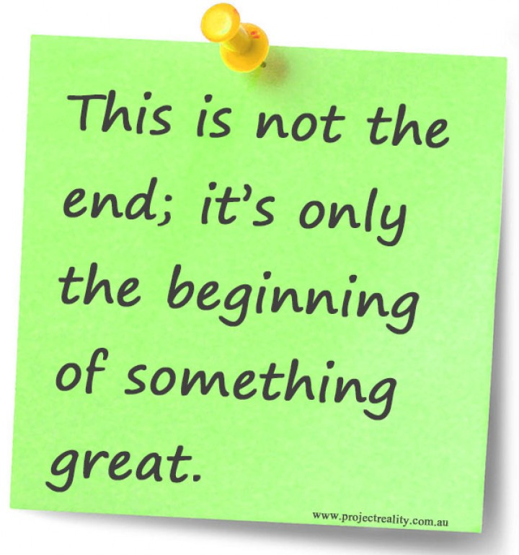
NYAPRS, 2017

