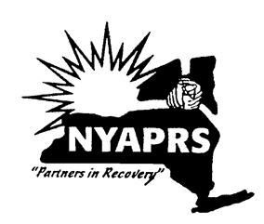
Going for the Goal!
Goal Setting for Getting Back on Track
PARTICIPANT GUIDE

Description
Going for the Goal is designed to allow participants to identify life-role goals by examining their hopes and dreams. Participants will review mental health recovery, their need for change, core values and how they can use their strengths to mitigate barriers. At the end of the course, participants will set at least one goal from which to work on. The course guides participants through a step by step analysis of who they are and where they want to go. It is recommended that each participant attend each session in order to fully engage in the process of determining their life-role goals.

Purpose
The purpose of this group is to explore personal interests and strengths to identify a life-role goal.

Class Objectives:
- Demonstrate an understanding of goal setting and the importance of future planning.
- Describe their hopes and dreams and develop hope for the future.
- Explore satisfaction level within several life domains and compare with their interests and values.
- Identify, at minimum, one goal area to pursue and the steps in which to achieve it.
SESSION ONE: Introduction to Course

Goals for Lesson One:
- Introductions to establish commonality and develop trust.
- Establish group norms to structure the conversations and support safety for all opinions and experiences to be heard without fear of judgement.
- Understand how recovery is for everyone.

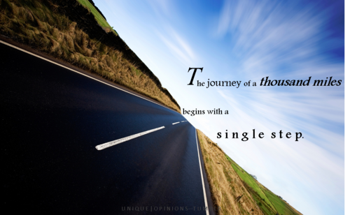

- Overview of Course
Description: Going for the Goal is designed to allow participants to identify life-role goals by examining their hopes and dreams. Participants will review recovery, their need for change, their values, strengths and set at least one goal from which to work on.

Purpose: The purpose of this group is to explore personal values, interests and strengths to identify a life-role goal.

- Introduction

The ‘My Name Is’ Ice Breaker Exercise
Think about an adjective that describes you and also starts with the same letter of your name. For example, Dynamic Dave.
Write it down here: __________________________________________________

- Group Norms/Rules – Write down the rules the group decides on.
________________________________________________________________________________________________________________________________________________________________________________________________________________________________________________________________________________________________________________________________________________________________________________________________________________________________________________________________________________________________________________________________________________________________________________________________________________________

- What Do We Have in Common?
Notes: ____________________________________________________________________________________________________________________________________________________________________________________________________________________________________________________________________________________________________________
- Why set goals?
Notes: ____________________________________________________________________________________________________________________________________________________________________________________________________________________________________________________________________________________________________________

- What is goal setting?
Notes: ____________________________________________________________________________________________________________________________________________________________________________________________________________________________________________________________________________________________________________

Skills + Supports = Success + Satisfaction

SESSION TWO: Recovery as the First Step

People don’t always think about ‘recovery’ from mental illness. It is a proven fact, that people can and do find recovery. The definition of recovery is different depending on who you ask. It is different because people are different and what you want out of life is different. Here are two definitions of recovery.

“Recovery is a deeply personal, unique process of changing one’s attitudes, values, feelings, goals, skills and or roles. It’s a way of living a satisfying, hopeful and contributing life even with limitations caused by illness. Recovery involves the development of new meaning and purpose in one’s life as one grows beyond the effects of mental illness.”
(Anthony, Cohen, Farkas, Gagne, Psychiatric Rehabilitation, 2002)

A process of change through which individuals improve their health and wellness, live a self-directed life, and strive to reach their full potential.
SAMSHA 2011

Recovery is the ‘gaining’ of something you desire in your life and not the removal of something. When thinking about what recovery means to you, remember that you are unique and that your vision of recovery for yourself will be different from others. With recovery, we welcome a new life with new possibilities.
Historically, people’s goals were focused on the ‘removal of symptoms’. Over time, we realized this was a limited view and only one aspect to a person’s recovery. We can achieve so much more when we do not limit our lives. If we decided to give up on our goals and our future until our symptoms were gone, we may very well never live a full life.
When we understand recovery, we learn that we are more than just a person with mental illness. We are people… people with hopes and dreams and we have every right to achieve them and live life to its fullest.
To understand recovery and how to live a life of our choosing, let’s look at recovery, as the first steps we take on our journey.

Recovery Principles
- Recovery is possible.
- Recovery can occur without professional intervention.
- Recovery involves more than symptom reduction and can occur even though symptoms reoccur.
- Recovery is not linear.
- Recovery is a highly individualized process.
- Recovery occurs in the presence of someone who believes in and stands by the person.
- Recovery from the consequences of the illness is sometimes more difficult than recovering from the illness itself.
Anthony, W.A. (1993) Recovery From mental Illness: The Guiding Vision of the
Mental Health System in the 1990’s. Psychosocial Rehabilitation Journal, 16 (4), 11-23
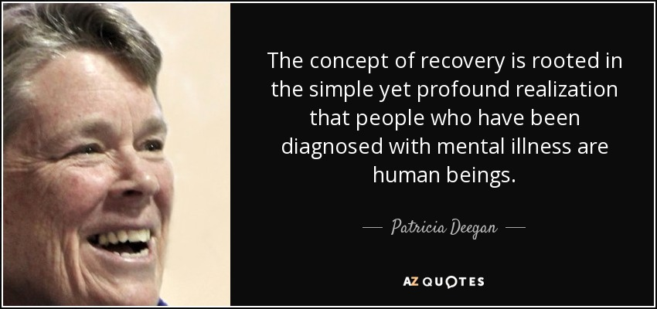

What does Recovery Mean to Me (Pat Deegan)?

To me recovery means I try to stay in the driver’s seat of my life. I don’t let my illness run me. Over the years I have worked hard to become an expert in my own self-care. Being in recovery means I don’t just take medications … rather, I use medications as part of my recovery process …
Over the years I have learned different ways of helping myself. Sometimes I use medications, therapy, self-help and mutual support groups, friends, my relationship with God, work, exercise, spending time in nature – all these measures help me remain whole and healthy, even
though I have a disability.
Pat Deegan, 1993

SOME PROFOUND EXAMPLES OF RECOVERY:

- Opening a bank account
- Not eating alone
- Buying cards and presents for family and friends
- Making meaningful contributions to the lives of others (giving back)
- Working, learning, loving, and playing like everyone else

Who is Recovery for? Everyone

Who is Pat Deegan?

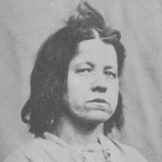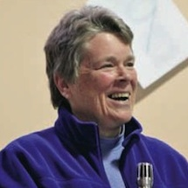

Patricia E. Deegan is a disability-rights advocate, psychologist and researcher. She is a thought leader, inspirational speaker and innovator in the field of mental illness. She is also a person who has mental illness, having been diagnosed with Schizophrenia as a teenager.
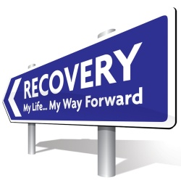
Exercise: What Does Recovery Mean to Me?
(3 Minute Exercise)

Let’s take a moment to write down our first impressions of what recovery means to you. This exercise is intended to be quick. Write down the first 3 things that pop into your mind as you think about what recovery means to you. Do not overthink your choices as this is not intended to limit any future options.

- _______________________________________________________________________________________________________________________________________________________________________________________________________________

- _______________________________________________________________________________________________________________________________________________________________________________________________________________

- _______________________________________________________________________________________________________________________________________________________________________________________________________________

We have all had dreams of what and who we wanted to be when we were younger. Those hopes and dreams can morph or change over time depending on our experiences. Some of us have experienced setbacks and we have put our hopes and dreams aside. They may even have changed from when we were young, but humans change and grow every day and so can we.

- Conclusion:
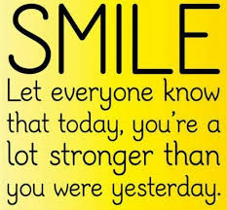
Recovery from mental illness does not mean the absence of symptoms, but it does mean going for your dreams. You may still have symptoms to overcome but you can live your best life while working to reduce your symptoms. You can manage symptoms various ways that include more than medication. It can include exercising, eating healthy, having friendships, being social and going out, talking with family, etc. To be able to live and work and have relationships; to have a life and to make mistakes and learn from them and to pick ourselves up again when we stumble. We all can live a full life when we think about ourselves and our WHOLE LIFE. We are more than an illness.

YOU are resilient and you can live your best life!

SESSION THREE: Exploring My Readiness for Change

It’s not easy to be certain if you even want to change any aspect of your life. Sometimes we know something is just not right. Our life is not what we planned or hoped it would be. But it’s sometimes easier to keep our life the same, even if we are not really happy with it. Today’s class will focus on our need for change and it will help us to identify what that is.

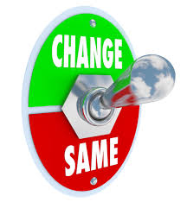
Mike’s Example of Need for Change

Name: Mike Smith

Step 1: Which area in my life do I want to focus on at this time?
Living Learning Working Social
Name of my Current Place and Role in this Area: Resident at Main Street Adult Home

Step 2: How happy am I with the people, the place, and the activities at my current place?

Need | Very Dissatisfied | Mostly Dissatisfied | Mixed | Mostly Satisfied | Very Satisfied
How satisfied am I with the people in my current place? |  | I don’t really like the other residents.
How satisfied am I with the physical aspects of my current place? |  | Nice TV, but I can’t watch what I want and I have to share a bedroom. I have no privacy. I can’t get healthy because I smell other people’s cigarettes.
How satisfied am I with the activities in my current place? | I’m bored w/ activities, and annoyed w/ chores.
Step 3: How well do I think I’m doing here? How well do others think I am doing here?
Need | Very Unsuccessful | Mostly Unsuccessful | Mixed | Mostly Successful | Very Successful
How successful do I think I am in my current place? |  |  | I think I’m okay. I do everything they ask me to but I have no choice.
How successful do others think I am in my current place and role? |  |  | Some + / - mixed reviews from others

Step 4: Given both my satisfaction and my success in my current place, how would I rate my need to choose a valued role now?
Circle One
Need for Change Rating | Very High | High | Moderate | Low | Very Low

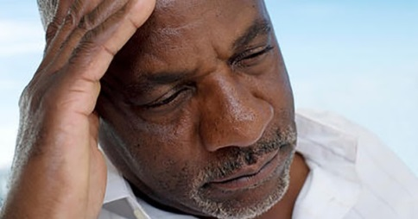
In this example, Mike chose a life area to focus on. He chose ‘Living’ and he answered the questions based on that. By going through this process, Mike is able to see that he is not very satisfied with his living environment. He is a resident in an Adult Home and while it’s a roof over his head, he can’t really do what he wants there. He has to share a television and that means he doesn’t always get to watch what he wants. He also has a roommate and that can sometimes be hard to deal with. He has very little privacy.
In the end, he rated his need for change as ‘high’. This now guides Mike as he plans to create a goal to change his circumstances.

Conversation Questions:
- Do you think this is how Mike imagined he would live?
- Can anyone relate to Mike’s dissatisfaction with living in an Adult Home?
- It’s called Adult Home, but do you think it feel like a ‘home’?
- Most people do not live in Adult Homes. What kind of places do people live in?
- Since Mike rated his dissatisfaction level at ‘high’, what do you think his goal should be?
- If Mike chooses to leave the Adult Home in order to be in his own place, what sort of things you think he needs to work on in order to achieve that goal?
- When Mike gets his own place, how do you think he will feel?
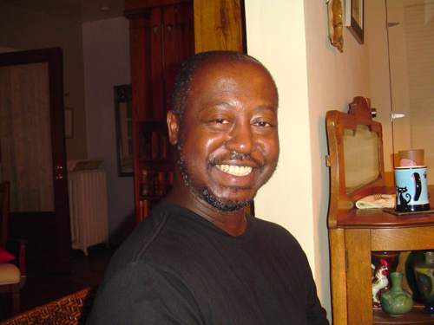
This looks like Mike is in his own place and he looks happy!

We will now go through this exercise ourselves. Use the blank ‘Need for Change’ form and answer the questions. Choose an area of your life that you want to focus on and then answer the questions. At the end, we will review your together and have a discussion based on your answers.

My Worksheets for My Need for a Change (page 1 of 2)

My Name: ____________________________________________________________________
Step 1: Which area in my life do I want to focus on at this time?
Living Learning Working Social
Instructions: Write down the name of where you are living, learning, working, or socializing. Write down your role there, such as resident, student, part-time cashier, club member, etc.
Name of my Current Place in my Area of Focus: ______________________________________
What is my Current Role here? ___________________________________________________

Step 2: How happy am with the people, the place, and the activities at my current place?
Instructions: Write your comments on the rating that best matches your satisfaction level for each of the qu3estions in the left-hand column. If you are not in the type of place you are focusing on, record how you feel about the lack of setting. For example, if you are unemployed, then how satisfied are you about having no job at this time?
Need | Very Dissatisfied | Mostly Dissatisfied | Mixed | Mostly Satisfied | Very Satisfied
How satisfied am I with the people in my current place?
How satisfied am I with the physical aspects of my current place?

How satisfied am I with the activities in my current place?

Step 3: How well do I think I’m doing here? How well do others think I am doing here?

Instructions: Write your comments in the box that best matches your success level for each of the questions in the left-hand column.
Need | Very Unsuccessful | Mostly Unsuccessful | Mixed | Mostly Successful | Very Successful
How successful do I think I am in my current place?

How successful do others think I am in my current place and role?

Comments:

Step 4: Given both my satisfaction and my success in my current place and role, how would I rate my need to choose a valued role now?
Instructions: Circle the rating that best describes your Need for a Change now based on your exploration of your satisfaction and your success. For example, a ‘Very High’ Need for Change rating means that you were very dissatisfied and very unsuccessful in your current place, and a ‘Very Low’ rating means that you were very satisfied and very successful in your current place.

Circle One
Need for Change Rating | Very High | High | Moderate | Low | Very Low

Homework Exercise (if applicable)
When you return to your Adult Home today, consider your experience in this class today and what you have discovered about yourself. Look around and think of what happens there to cause you to be dissatisfied and then think of your living on your own. Ask yourself this question: How would my life be enhanced by living on my own? During the next class, we will discuss how this homework exercise went.

How would my life be enhanced by living on my own?
____________________________________________________________________________________________________________________________________________________________________________________________________________________________________________________________________________________________________________________________________________________________________________________________________________________________________________________________________________________

SESSION FOUR: Personal Core Values

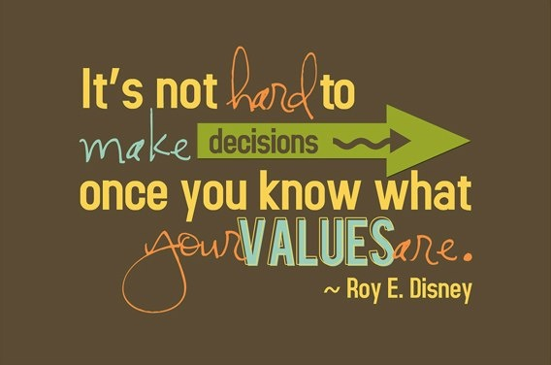
Roy Disney is co-founder of the Disney franchise with his brother, Walt.

- Core Values
Understanding values entails having a clear sense of what we care about. When we are connected to our values, we will have a clearer understanding of what motivates our behavior. Values define what is important to us. They are reflected in our hopes, dreams, desires, goals, and ambitions. Values, like feelings, indicate who we are. Values are an extension of our beliefs about the world and attitudes toward life. They are formed over time through a series of life experiences, including our interactions with family, school, and community. Values provide guidelines for making decisions that are right for us. Understanding the specific values that guide our behavior helps us to clarify the significance of more general values, such as those pertaining to family, work and spirituality.
Some values play such a central role in life that it would seem we should be able to articulate them clearly. Unfortunately, some of us can’t. We may have a vague idea of what is important to us and live our lives based on an imprecise understanding of our values. When we suffer from inner conflict, it is usually because we are unsure of our values and we do not know how to decide which values are the most important.

People often confuse goals and values but in reality they are quite different. Goals tend to be specific and achievable, and they can be checked off and completed. Values represent what is important to you in life and they tend to be constant. Values cannot be completed or finished. Goals are successful when they are based on our values. For example, if family relationships are an important value, some related goals could be to reconnect with a family member; or to increase time you spend with family, etc.

Examples of life values:

- A belief, or lack thereof, in God and/or an affiliation with a religious institution
- A belief in being a good steward of resources and in exercising frugality
- A belief that family is of fundamental importance
- A belief that honesty is always the best policy and that trust has to be earned
- A belief in maintaining a healthy work/life balance

Hope grows when we realize that we have the ability to act in accordance with our values, and when we believe that our values can be realized within the world.

Identifying Our Values (there are 2 exercises to choose from)
Our core values are the true representation of our authentic selves. Unfortunately, our authenticity is not always what we present to the world. The bright beacon of core values may dim under clouds other people and circumstances cast over them. That is why it is important to know and stand firm on what your core values are. If you put a small value on your core values, I can assure you that the world will not raise your price.
It doesn’t take years of soul searching and self-reflection to find your core values. The following exercise can help you start living your best life according to your core values in 30 minutes or less.
Grab a pen and piece of paper and let’s go!

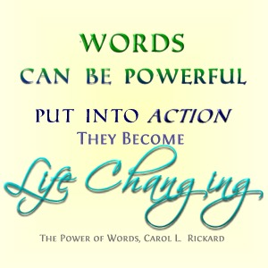

Exercise Option 1:

In the space below, write down your physical, emotional, intellectual, and spiritual values relative to home or work – then weight them according to their relative level of importance. Use a 10 to indicate your most important values and 1 to indicate your least important values. Assign relative weights to all the others. You can use the same number more than once. Pick two or three values for each category. You can use the list of some possible Core Values to help you with this exercise.

Example from Mike Smith
Physical Values: |  | Intellectual Values:
Fitness | 8 | Contribution | 7
Appearance | 6 | Quality | 8
Activity | 5 | Challenge | 6
Emotional Values: |  | Spiritual Values:
Adventure | 7 | Meaning | 10
Love | 10 | Trust | 10
Commitment | 10 | Forgiveness | 7

Physical Values: |  | Intellectual Values:
Emotional Values: |  | Spiritual Values:

List of Some Core Values

Acceptance  Accountability  Achievement  Adventure  Advocacy  Ambition  Appreciation  Attractiveness  Autonomy  Balance  Being the Best  Benevolence  Boldness  Brilliance  Calmness  Caring  Challenge  Charity  Cheerfulness  Cleverness  Community  Commitment  Compassion  Cooperation  Collaboration  Consistency  Contribution  Creativity  Credibility  Curiosity  Daring  Decisiveness | Dependability  Diversity  Empathy  Encouragement  Enthusiasm  Ethics  Excellence  Expressiveness  Fairness  Family  Friendships  Flexibility  Freedom  Fun  Generosity  Grace  Growth  Flexibility  Happiness  Health  Honesty  Humility  Humor  Inclusiveness  Independence  Individuality  Innovation  Inspiration  Intelligence  Intuition  Joy | Knowledge  Leadership  Learning  Love  Loyalty  Making a Difference  Mindfulness  Motivation  Optimism  Open-Mindedness  Originality  Passion  Performance  Personal Development  Proactive  Professionalism  Quality  Recognition  Risk Taking  Safety  Security  Service  Spirituality  Stability  Peace  Perfection  Playfulness  Popularity  Power  Preparedness  Proactivity | Punctuality  Relationships  Reliability  Resilience  Resourcefulness  Responsibility  Responsiveness  Security  Self-Control  Selflessness  Simplicity  Stability  Success  Teamwork  Thankfulness  Thoughtfulness  Traditionalism  Trustworthiness  Understanding  Uniqueness  Usefulness  Versatility  Vision  Warmth  Wealth  Well-Being  Wisdom  Zeal

Exercise Option 2:
In this exercise you will be using the skill of understanding your values by placing them in the context of your life.

To help you focus on your values, assume for a moment that you have won the lottery. Write (or use a verbal interactive style) a story about what you would do with the money. Use these thoughts to get an even clearer picture of what is important to you.

- What would you do with your time?
- Where would you go?
- With whom would you spend your time?

Clarifying Values
Clarifying Values broadens our knowledge about what is and what is not important to us. We need to know what is important to us before we choose an environment. The more our chosen environment matches our values, the more likely we will be satisfied with our choice.

SESSION FIVE: Using My Strengths to Overcome Barriers

The previous session on our Core Values was the first step in helping you to identify a goal (or goals) that you are most interested in achieving. When you are able to connect your values to your goals and to understand the connection, you get to know a little bit more about yourself.

We want to examine our identified Core Values from the previous session.

Write down the Core Values you identified during the last class:
______________________________________________________________________________________________________________________________________________________________________________________________________________________________________________________________________________________________________________________________________________________________________________________________________

Personal Strengths: We’re now going to jump into examining our Personal Strengths. We all have different personal strengths and abilities. Sometimes it can be hard to remember them when we are going through tuff times. Knowing our strengths will help us work towards and accomplish the things you want from your life. The following statements may help you identify some of your own.
My Personal Strengths Exercise:

My best qualities as a person are ___________________________________________________
____________________________________________________________________________________________________________________________________________________________

Something I would NOT change about myself is _______________________________________
____________________________________________________________________________________________________________________________________________________________

I am most proud of ______________________________________________________________
____________________________________________________________________________________________________________________________________________________________

My sense of humor is ____________________________________________________________
____________________________________________________________________________________________________________________________________________________________

The times I am most at peace are when _____________________________________________
____________________________________________________________________________________________________________________________________________________________

People like that I am (people say they like my…) _______________________________________
____________________________________________________________________________________________________________________________________________________________

I feel really good about myself when ________________________________________________
____________________________________________________________________________________________________________________________________________________________
- Using our Strengths to Get Back on Track

Recovery is deeply personal and it helps us to move on from moments in our past where life took a turn we didn’t expect. Recovery gives us hope and courage to face the path you set for yourself. It is a journey we all experience at some level and at various times in our lives. Barriers have the ability to stop us in our tracks and we - - get off track in our lives. We have all been there. That is one thing we all have in common with each other.

The next phase is to beginning planning our future. Planning takes courage and we are all courageous! We will get back on track by creating goals we want to achieve. We will use all the information we learned about ourselves throughout this course so far to plan our future. As in all things, we want to take this one step at a time in order to be mindful of barriers and work our way through them by using our strengths.

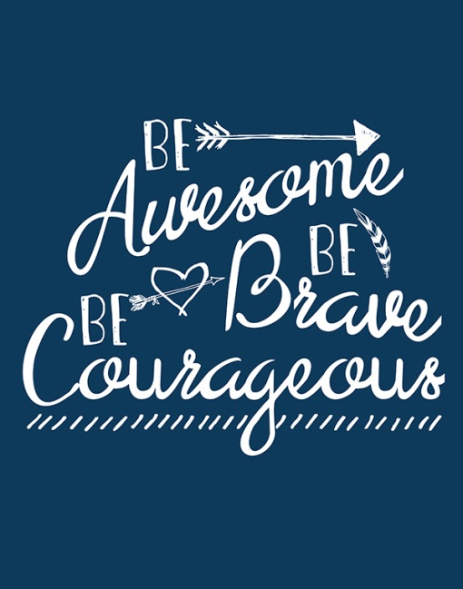
Example: Strengths and Barriers
I may encounter a problem with a family member, who disagrees with my decision to live on my own. I know that my family loves me but they keep thinking about my past. How can I help them see that my future is not defined by my past?

- I have some strengths I can call upon!
- I love my family.
- I am scared about them being upset with me but I can communicate my hopes and dreams to them.
- I am determined to achieve my goal of living on my own.
- I am proud of myself for making this decision!
- I am an understanding person so I know that my family loves me even if they are upset.
- I am resilient and I know I will be able to live on my own with help.
- I will accept support from family, friends, church, community, PROS, Care Management, etc. to help me be successful.
- I am motivated to learn the skills I need to be successful.
- I am scared but I am prepared to be in control of my life.
- I will remember that my family loves me even if we disagree.
Using My Strengths to Overcome My Barriers Exercise:

You can use the list of Core Values to help you.
A barrier I may encounter is:

______________________________________________________________________________________________________________________________________________________________________________________________________

Strengths Statements
1.
2.
3.
4.
5.
6.
7.
8.
9.
10.
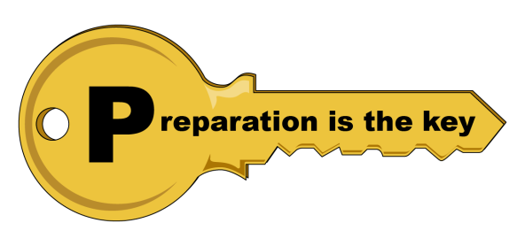

I’m ready to write my goals!

WONDERFUL! The rest of the class will focus on honing down your goal so that it’s not too broad or too unmanageable. As we discussed, we want to prepare for the barriers that may get in our way to living our goal. Goal statements with incremental steps help us to have more control of the process. It also helps us to feel successful! When one piece of the goal is completed, celebrate because you will be one step closer to your goal!

SESSION SIX: My Goals

RECAP:
In the last five classes, we’ve discovered a lot about ourselves! We have explored areas that we would like to change. We’ve explored our values, feelings, potential barriers and our personal strengths we can use to face them.
All of this knowledge will be put into action today! We will determine our goals and write them out.

Exercise: What if I Still Have No Goals? No Sweat! (5 minutes)
Ask each person (whether they have goals or not) to visualize an ‘ideal day’. The duration of this exercise is short because this is intended to capture a person’s first thoughts.

- What would this look like? ____________________________________________________________________________________________________________________________________________________________

- What would you be doing? ____________________________________________________________________________________________________________________________________________________________

- Who would be with you? ____________________________________________________________________________________________________________________________________________________________

- Generating Person-Centered Goals
What do we mean by Person-Centered goals? Well, this is typically when goals are stated in your own words and using positive strengths-based language, e.g. “I want to be less depressed so that I can finish college.” The ‘less depressed’ part of the goal focuses on symptoms but that alone is not a goal. A goal includes identifying a life-role that you want to achieve. In this example, the person wants to be less depressed so that they can become a student to finish college.

Advice: You may find that a goal you create is not quite in keeping with a clinician’s idea of a goal for you. This is okay and it’s a perfect time to have a discussion together. These are your goals. Clinician’s want you to be successful, and we may have some opinions. We will explore this with you by asking you questions to help you think about and consider your choices and options. By having a discussion with a staff member, this will allow you to get additional input and ideas. In the end, the goal is yours.

“To be able to participate in person-centered care, first you have to believe that you have the right to be a person” - - Ed Knight

PUTTING IT ALL TOGETHER

We’ve achieved so much!
- Which area of my life do I want to focus on at this time?
Living Learning Working Social

- I have identified my Need for Change Rating
- I have identified my core values
- I have identified my personal strengths
- I have identified how my personal strengths can help me overcome a potential barrier

The next step is to write my goal statement!
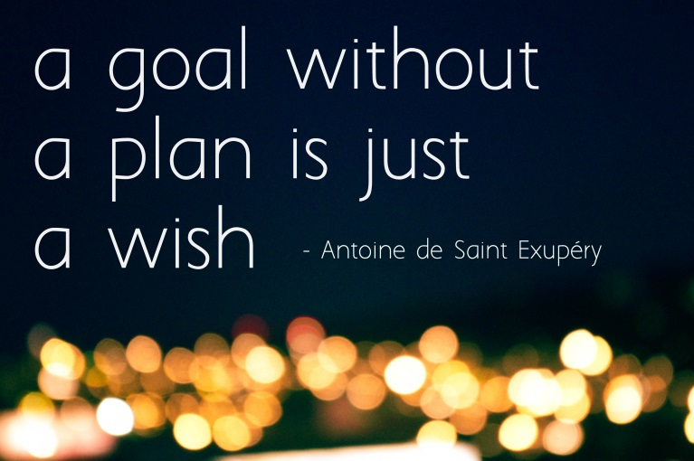

My Goal Setting Worksheet

Name: Mike Smith
Life Area to Improve:
Living Learning Working Social

What are my top 3 values?
- Love
- Meaning
- Trust

MY GOAL IS TO:
Live in my own apartment.
Steps I can take to reach my goal | By when | Who can help | Completed?
1. Apply for and obtain a Care Manager | 1 month | PROS Staff
2. Ask for help from the Care Manager or the Ombudsman who visit my residence | 2 months | Myself
3.Complete an application for Supported Housing. | 3 months | Care Manager, Peer Support, or PROS staff
4.Visit available apartments | 5 months | Care Manager or Peer Support staff
5. Submit my One Month’s Notice to the home | 7 months | Care Manager or Peer Support staff
6. Sign lease and move in | 8 months | Care Manager or Peer Support staff

My Goal Setting Worksheet

Name: ___________________________________ Date: __________________

Life Area to Improve:
Living Learning Working Social

What are my top 3 values?
- _____________________________________________
- _____________________________________________
- _____________________________________________

MY GOAL IS TO:
Steps I can take to reach my goal | By when | Who can help | Completed?
1.
2.
3.
4.
5.
6.
Other examples of Goal Statements:

RESIDENTIAL
- I will live as a resident of a Community Residence by month/day/year.
- I intend to live as a resident of the Crossroads apartments by month/day/year.
- I will live with my wife in my own home by month/day/year.

VOCATIONAL
- I will work full-time as an Assembly Line Worker, at the Stride-Rite shoe factory as of month/day/year.
- I will work at Shop-Rite supermarket as a Stocker as of month/day/year.
- I will get along better with my co-workers for the next month.
- I will perform my job duties in order to keep my job.

EDUCATIONAL
- I will be a student at the Secretarial BOCES program as of month/day/year.
- I will obtain a Peer Specialist Certification by month/day/year.
- I will obtain a Mechanic Certification at BOCES on or before month/day/year.

SOCIAL
- I will socialize with people at the local library Book Club as of month/day/year.
- I will be a member of the Eighth Avenue YMCA as of month/day/year.
- I will go on a date with at least one person as of month/day/year.

CLASS CLOSING:
Congratulations! You have reached the end of the course and you have successfully created goals that are in keeping with your needs, values and strengths.

Now that the hard work of identifying goals is over, it is important to ensure that this information makes its way to the clinician you are working with. With your permission, the group facilitator will make a copy of ‘My Goal Setting Worksheet’ to give to your clinician.

You should keep the original copy along with all the other materials you completed during this course. When you feel doubtful or discouraged, pick up your materials and review them. Remind yourself that you are worth it!

Congratulations!
You are Going for the Goal!

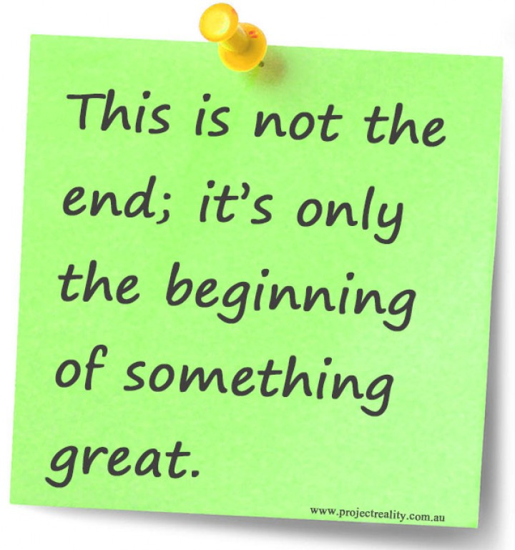
NYAPRS, 2017

