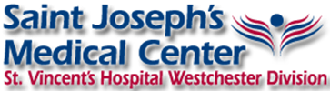
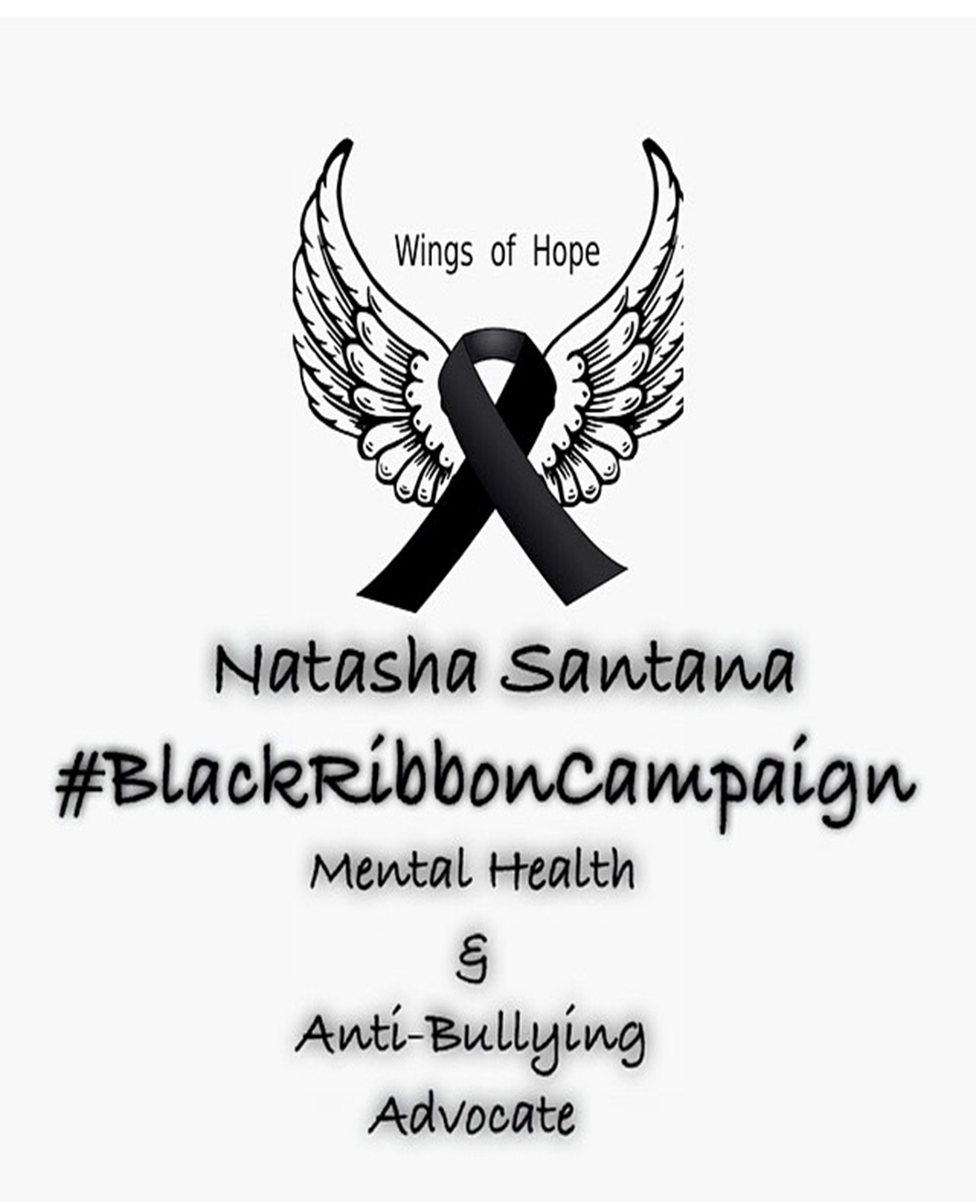
Are you ready to action? Some of these actions you can take are simple like reading inspirational quotes that reminds us that we aren’t alone. Other actions might involve your community. Some actions are very personal, like reaching out to a friend you know needs support or speaking up because you are having a hard time. I’m so excited to be running a safe haven for you. I will be taking the pledge to reach out to many individuals dealing with depression, self-injury, anxiety, etc. I’m taking this pledge because I know what it’s like to feel alone, to feel weak, and in pain. Even though I’m still recovering from my mental health issues I want to be able to help others and tell them they are not alone and they will get through their pain. Since I am still working on certain issues, I feel like it’s better to talk to that person who has or still are dealing with these problems. That’s where I come in! I am living proof! I’m here to help, listen, and guide your way to peace. When things get tough, contact me:
Facebook: https://www.facebook.com/NatashaSantanaMusic
Instagram: http://instagram.com/_santanaofficial
Twitter: http:/ /twitter.com/PeaceLuvEmma

Stay Strong
Black Ribbon Campaign Curriculum

